200A 4XDW Connector Specification
 | Juheng technologies co. Ltd |  | Lithium battery module connector
Ⅰ、Product appearance
Positive pole:JH-LJ-200A-4X-DW-R  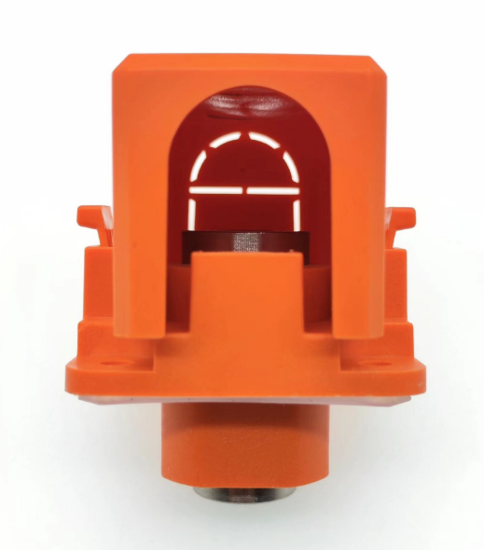 |  | Negative pole:JH-LJ-200A-4X-DW-BK  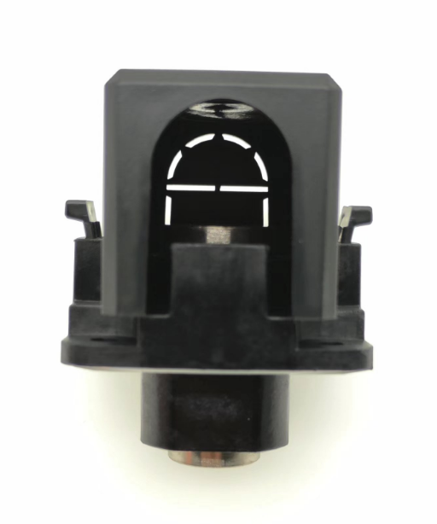
Ⅱ、Performance parameter：
1、Electrical parameters
■ Rated Voltage：1000V DC
■ Rated current：200AMP
■ Withstand voltage：3500V DC
■ Insulation Resistance：≥500MΩ
■ Contact Resistance：≤0.5mΩ

2、Mechanical parameter
■ Contact surface diameter：18mm
■ Aperture of external screw：M8
■ Internal screw aperture：M6
■ Tightening torque: M6 Threaded hole (Coarse thread)：9N.m MAX,M8-12N.m MAX

3、Materials composition
■ Conductor: brass, nickel plated
■ Insulating material：PA66 Flame retardant V0 Level
■ Insulation parts thermal deformation temperature：205℃
■ Color：Positive pole orange color / Negative pole black color
■ Sealing ring: silicone

Ⅲ、External dimension
Units：mm
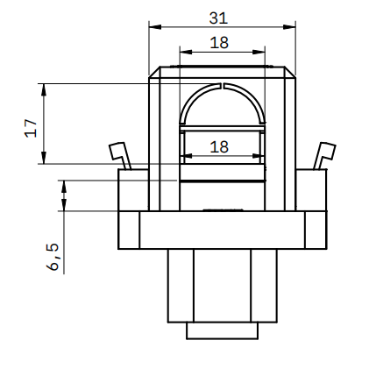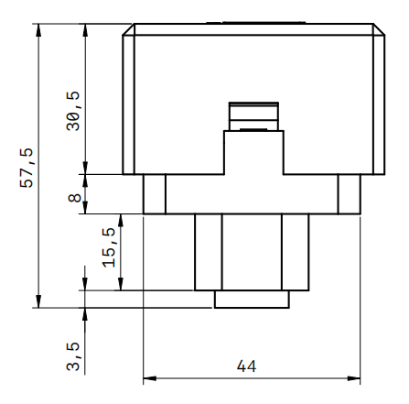

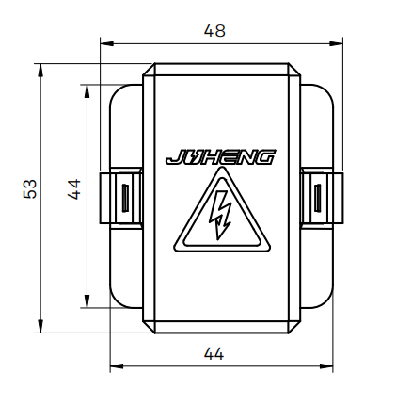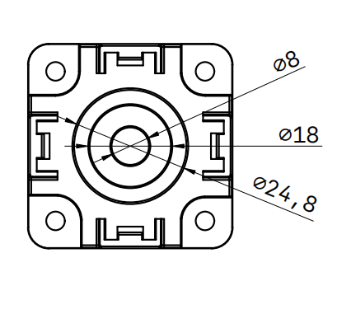

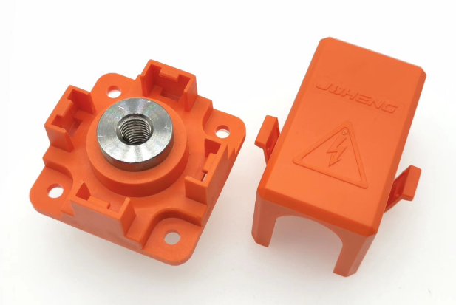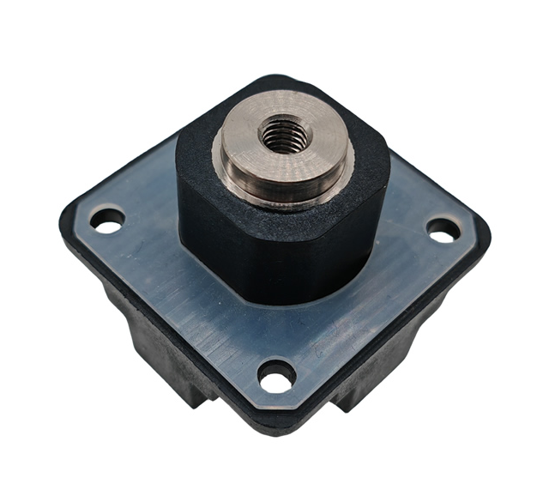

Ⅳ、Installation trepanning
- Units:mm
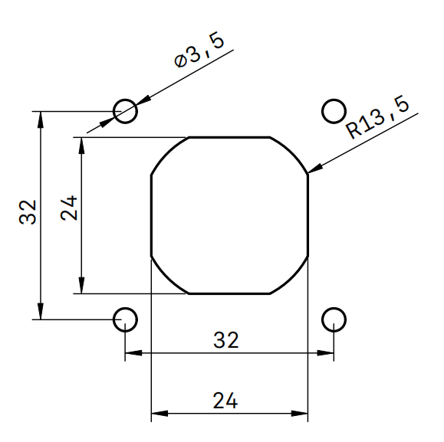
Juheng technologies co. Ltd

